Professional Women in Building : PWB NEWS
We are all experiencing a very different work environment these days. If PWB members are representative of the industry, we are incredibly busy.
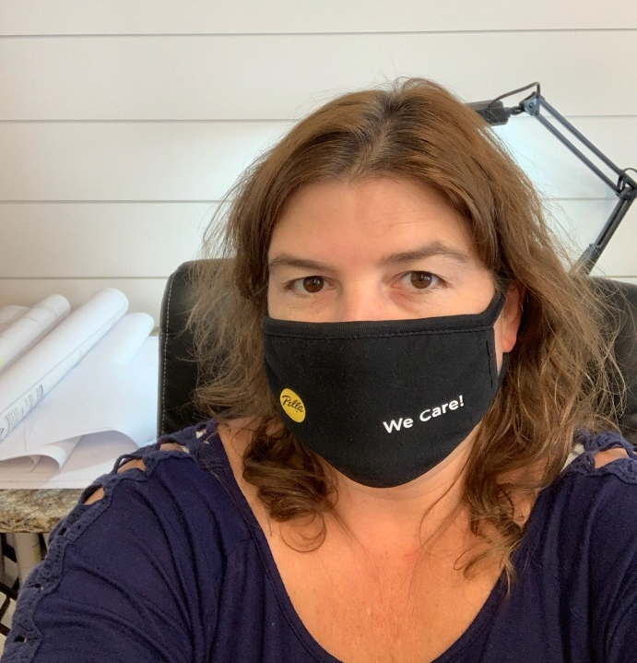
We need to keep working, and we need to stay healthy. Be creative with your masks, but mostly be sure to keep your distance and stay safe! 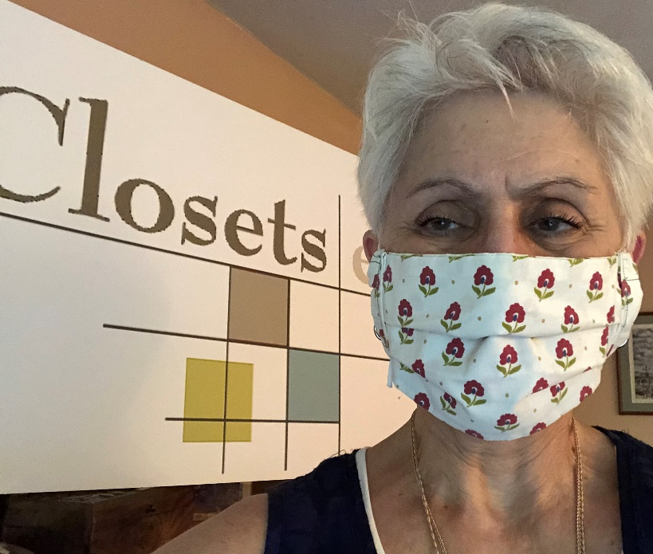 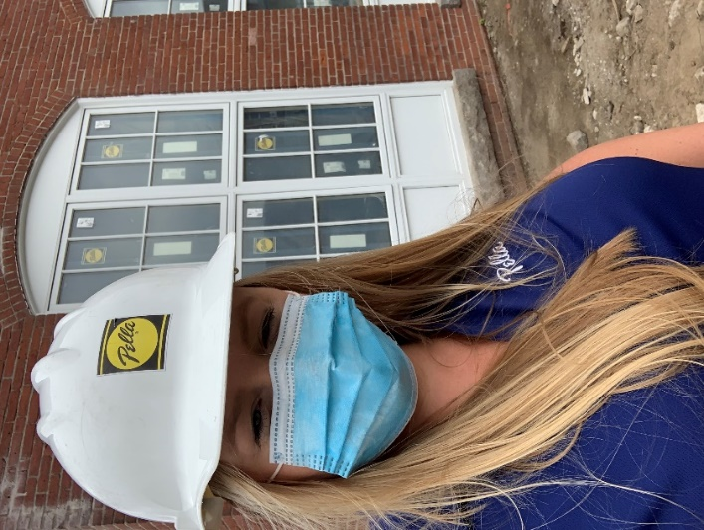
PWB Officers
Want to learn more about the PWB?
Please visit our site for contact info, up-coming events and news at http://ribuilders.org/professional-women-in-building

Carol O’Donnell-President
Linda Bohmbach- Vice President
Sophia Karvunis- Treasurer
Jacqueline Pagel- Secretary

