Professional Women in Building : PWB NEWS
We are all missing seeing each other and sharing our experiences. We can’t wait until it is safe enough to schedule our meetings again. In the meantime, stay safe, be well, and keep your spirits up, ladies!
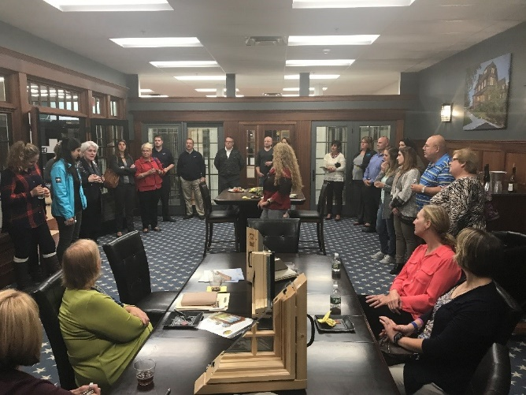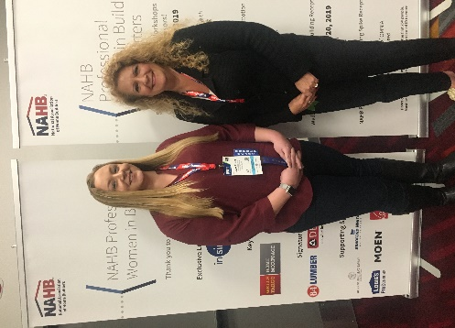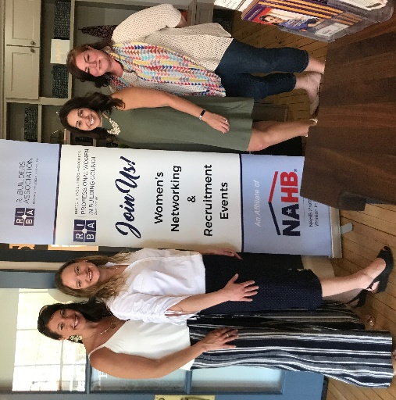
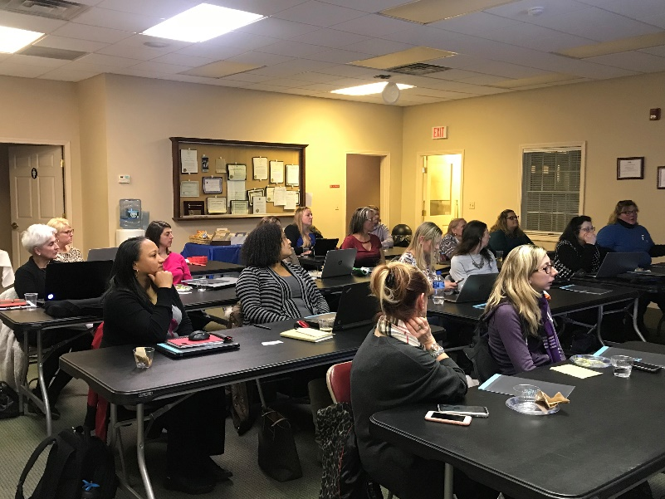
Smithfield Plumbing Networking Event
Fall 2020 Date TBD
PWB Officers
Want to learn more about the PWB?
Please visit our site for contact info, up-coming events and news at http://ribuilders.org/professional-women-in-building

Carol O’Donnell-President
Linda Bohmbach- Vice President
Sophia Karvunis- Treasurer
Jacqueline Pagel- Secretary

