Professional Women in Building : PWB NEWS
Happy Independence day
from your PWB Council!
We look forward to seeing you this Fall. Stay well and be safe.

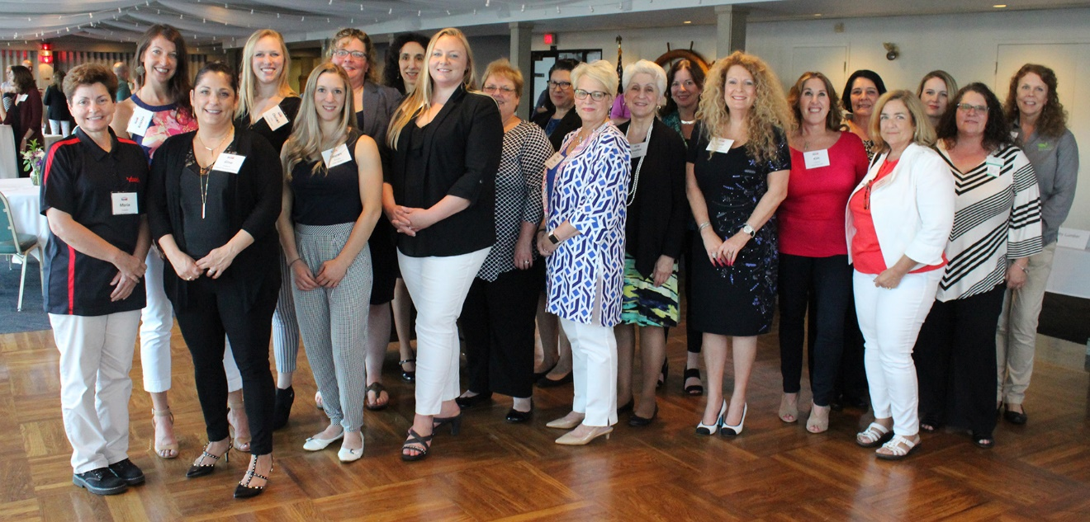
Smithfield Plumbing Networking Event
Fall 2020 Date TBD
PWB Officers
Want to learn more about the PWB?
Please visit our site for contact info, up-coming events and news at http://ribuilders.org/professional-women-in-building

Carol O’Donnell-President
Linda Bohmbach- Vice President
Sophia Karvunis- Treasurer
Jacqueline Pagel- Secretary

