Professional Women in Building : PWB NEWS
We want to wish our members a wonderful Summer Season! We look forward to networking again soon.
Please enjoy these photos from past events and know we are stronger together! Stay safe. Be well.
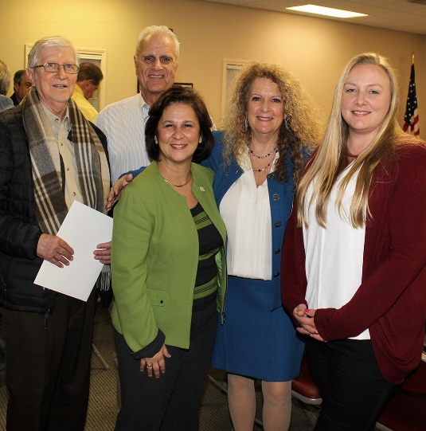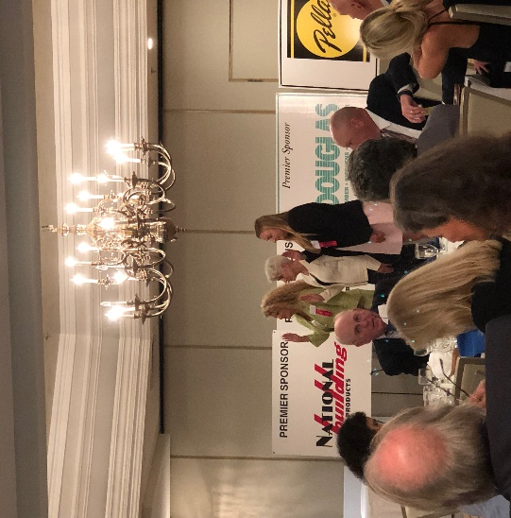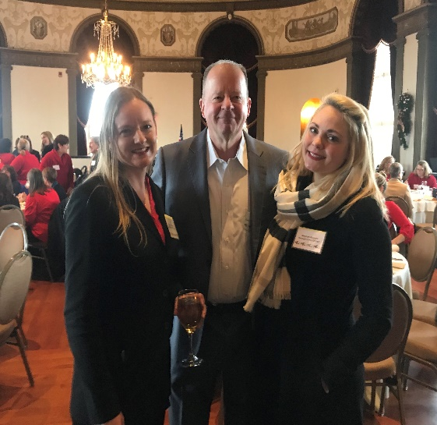
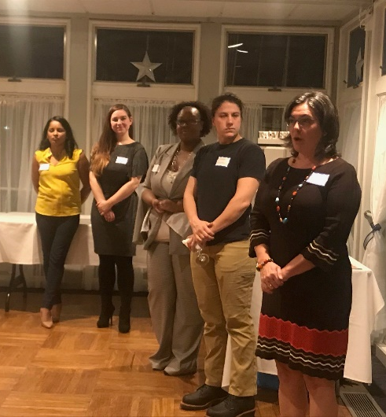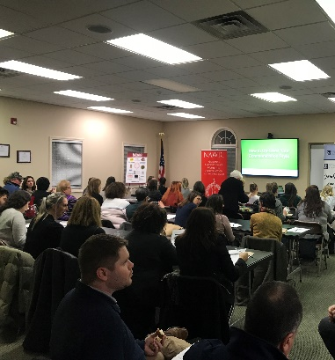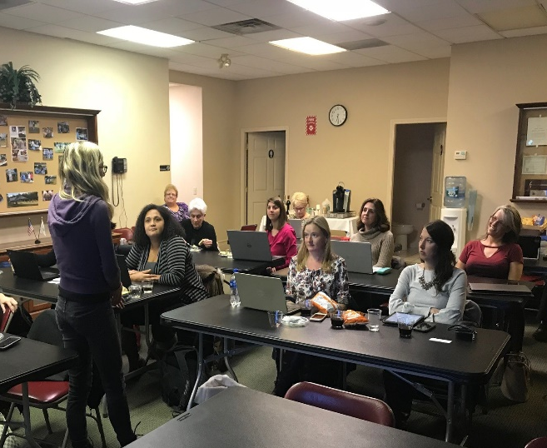
Smithfield Plumbing Networking Event
Fall 2020 Date TBD
PWB Officers
Want to learn more about the PWB?
Please visit our site for contact info, up-coming events and news at http://ribuilders.org/professional-women-in-building

Carol O’Donnell-President
Linda Bohmbach- Vice President
Sophia Karvunis- Treasurer
Jacqueline Pagel- Secretary

