Professional Women in Building : PWB NEWS
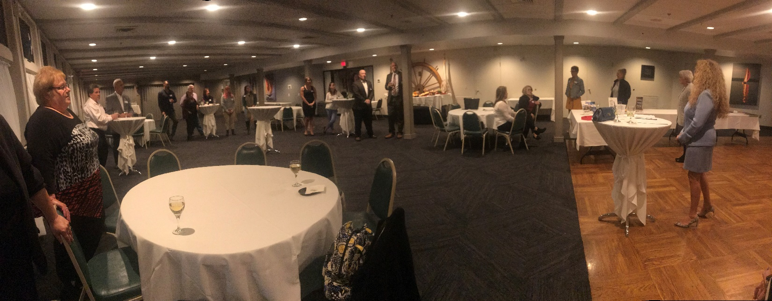
Members and guests gathered for our Fall Social Member Spotlight networking event at the East Greenwich Yacht Club. Members showcased their business, networked, and we raised funds towards our PAC. Thank you to all who made this event such a success. We look forward to next year!
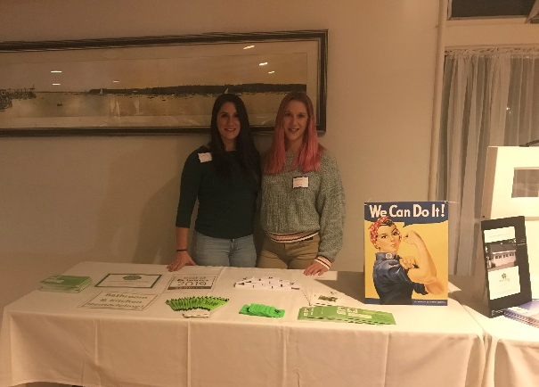
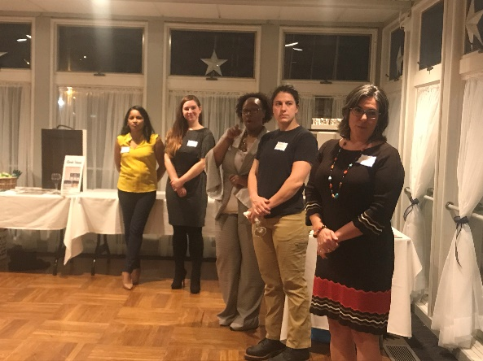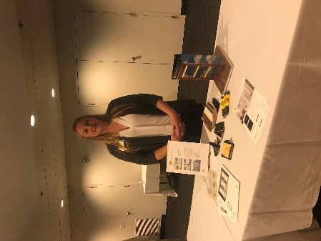
Save the Date
NAWIC Annual Holiday Brunch
The Graduate Hotel (formerly The Biltmore)
In the Grand Ballroom
December 13, 2019 11:30am-3pm

PWB Officers
Want to learn more about the PWB?
Please visit our site for contact info, up-coming events and news at http://ribuilders.org/professional-women-in-building

Carol O’Donnell-President
Linda Bohmbach- Vice President
Sophia Karvunis- Treasurer
Jacqueline Pagel- Secretary

