Professional Women in Building : PWB NEWS
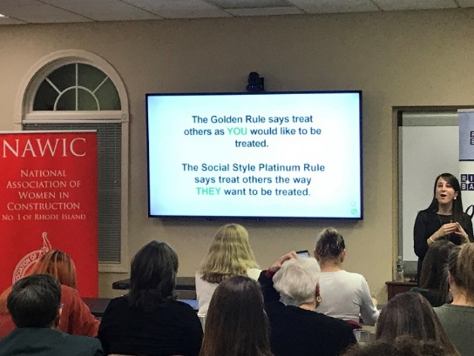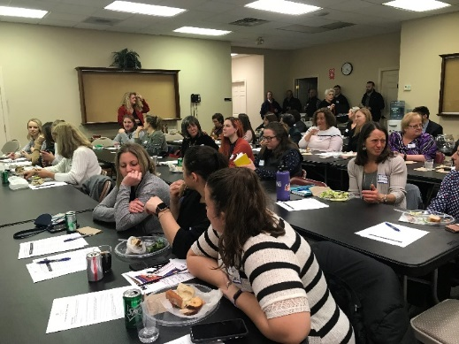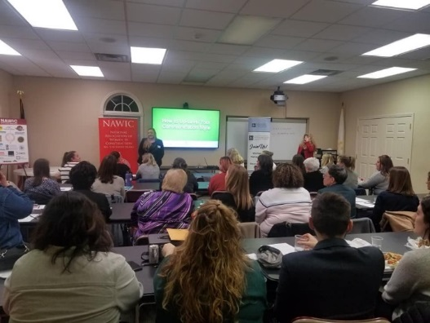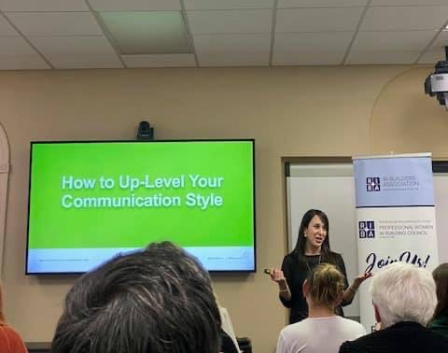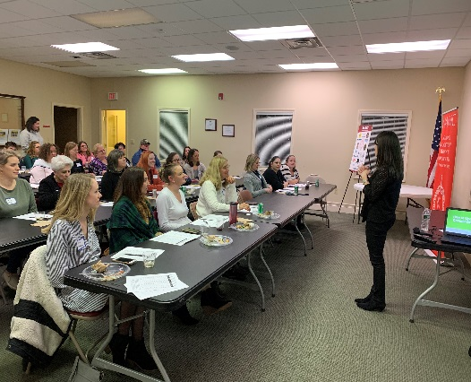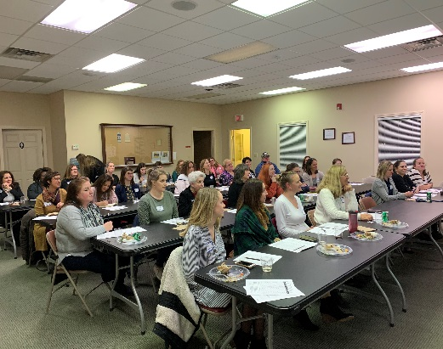
In January the PWB and NAWIC RI held a successful Professional Development joint meeting at RIBA headquarters! We filled the room for our guest speaker, Carrie Majewski of Women’s Leadership Nexsus. She presented How to Level-Up Your Communication Style.
Up-Coming Events
April 2-5 70th Annual RIBA Homeshow Providence Convention Center
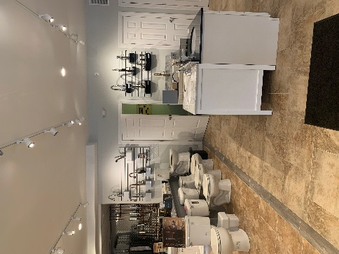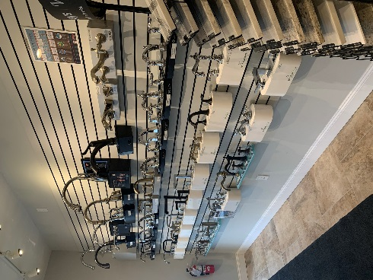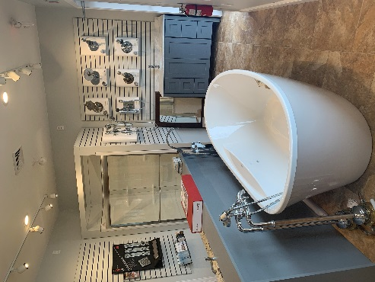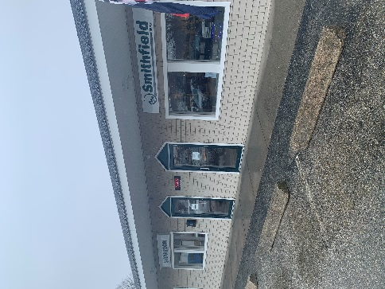
April 21 – 6-8pm Smithfield Supply – 1 Austin Ave, Greenville, RI

PWB Officers
Want to learn more about the PWB?
Please visit our site for contact info, up-coming events and news at http://ribuilders.org/professional-women-in-building

Carol O’Donnell-President
Linda Bohmbach- Vice President
Sophia Karvunis- Treasurer
Jacqueline Pagel- Secretary

